**TF LUNA LIDAR REPORT**

* **Temp Range:**
  + Operating Range: -10 ~ 60 Celsius
  + Storage Range: -20 ~ 75 Celsius
* **Principle:**

TF-Luna uses Time of Flight (TOF) principle to measure the distance, and it periodically emits near infrared modulated waves. TF-Luna calculates the time by measuring the phase difference between the original wave and the reflection wave and uses that time to get relative distance.

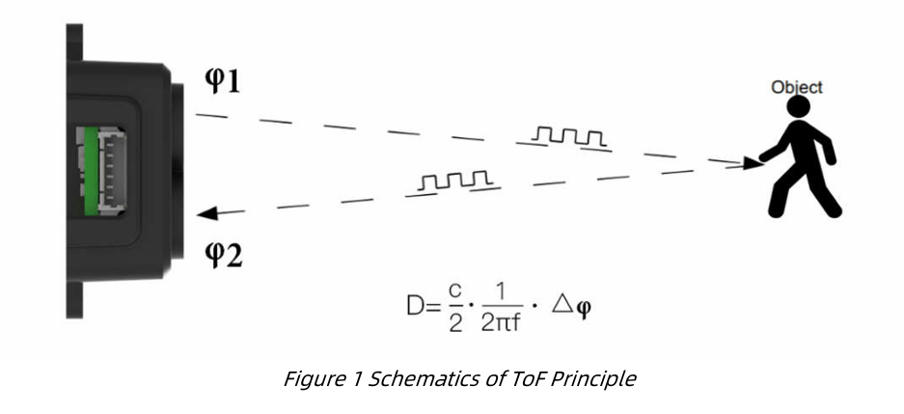

$$∅=Phase Difference$$

D= Distance travelled

c = speed of light

* **Standard Deviation: Based on Signal Strength**

Signal Strength of TF-Luna is measured in **strength value (Amp**) and refers to the reflected infrared light.

It plays a crucial role in determining **the accuracy of distance measurements**.

* **Higher Amp values indicate stronger signal reflections, leading to more reliable distance readings.**
* **Lower Amp values can result in inaccurate measurements, especially if the signal is too weak or overexposed.**

**Standard Deviation (STD) for 100Hz output frame rate**

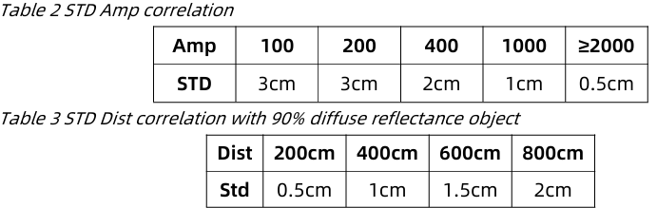

*Note Values may differ in real environment due to different environmental factors*

**Environmental Factors which affect the signal strength**:

1. Measurement of Accuracy –

* High Amp values => Lower STD => Better accuracy
* Lower Amp values =>Higher STD => Noisy or inconsistent readings

1. Impact of Surface Reflectivity -

* Dark /non-reflective surfaces => Low Amp => Low accuracy
* Bright/highly reflective surfaces => High Amp=> Improved accuracy

1. Environmental Conditions –

Dusty/foggy/cloudy/poorly lit => Low Amp => low accuracy

Direct sunlight / Bright surfaces can overexpose Amp (>32768) => distance measurements unreliable

* **Range Measurements:**

Imp points to Notes:

1. TF-Luna’s blind zone is 20cm => distance<20cm = unreliable
2. Operating Range of Black & White Targets is different:

The operating range of TF-Luna detecting black target with 10% reflectivity is 0.2-2.5m.

The operating range of TF-Luna detecting white target with 90% reflectivity is 0.2-8m.

1. The ranging data is reliable only if the reflection surface fully covers the light spot.
2. The diameter of the light spot depends on the FOV (field of view) of TF-Luna.
3. The minimum diameter of the object surface can be determined by the following formula:

$$d=2D\tan{β}$$

d = minimum diameter of the object surface

D = Distance of the object surface

$$β=half FOV of TF-Luna$$

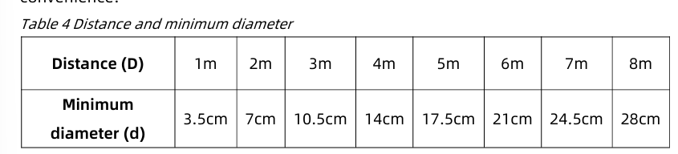

* **PINOUT CONFIGURATIONS:**

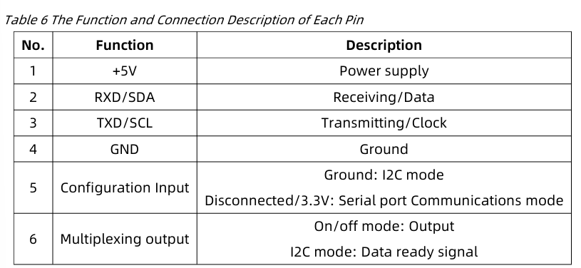

* **Basic Data Outputs:**

1. Distance (Dist.) – Default in centimeters (cm).
2. Signal Strength (Amp) – Distance value is unreliable when the receiving signal is **overexposed (Amp = 0xFFFF)** or too low (Amp <100).

**Normal conditions => Amp <30,000**

**Amp > 32768 => detection of ambient light overexposure** (when TF-Luna is in direct contact with sunlight)

1. Temperature Range – 8 ~ 256 Celsius

* **Operating Modes for TF-Luna:**

1. ***Continuous Ranging Mode* -**

* **Description**: TF-Luna continuously measures distance at up to 500 Hz, then outputs averaged results at a user-set frame rate (500 Hz / n). Lower output frequency increases averaging and stability.
* **Default**: 100 Hz. Supported frequencies are 250, 166, 125, 100, …, 2, 1 Hz.
* **Configuration**: Send serial command ID_SAMPLE_FREQ (0x03) with desired frequency; then **save** (ID_SAVE_SETTINGS) to persist across power cycles.

1. ***Trigger Mode* -**

* **Description**: Measurement and output occur only when explicitly triggered. Useful for synchronous sampling or ultra-precise timing.
* **Enable**: Set output frequency to 0 via ID_SAMPLE_FREQ=0x03.
* **Trigger**: Send 0x5A 04 04 00 (ID_SAMPLE_TRIG) to initiate one measurement.

1. ***On/Off Mode* -**

* **Purpose**: Object-presence detection without distance values. Pin 6 outputs a digital level indicating “object closer than threshold” or “object farther than threshold + hysteresis”.
* **Parameters**:
  + **Dist**: switching threshold (cm)
  + **Zone**: hysteresis band (cm)
  + **Delay1/Delay2**: debounce times (ms) for entering/exiting the zone
* **Enable**: Use ID_ON_OFF_MODE=0x3B, supplying Mode (0=normal, 1=high-level when closer, 2=low-level when closer), Dist, Zone, Delay1, Delay2, then **save**.

1. ***Power Saving Mode (ECO)* -**

* **Description**: Internally auto-triggers measurements at up to 10 Hz, reducing average power by lowering duty cycle.
* **Current Consumption**: ~60 mW at 10 Hz; ~44 mW at 1 Hz (5 V supply).
* **Enable**: Send ID_LOW_CONSUMPTION=0x35 with desired sample rate (1–10 Hz), then **save**.

1. ***Ultra-Low Power Mode* -**

* **Goal**: Minimize standby current (~1.5 mW) by putting MCU to sleep; wake only to take a single measurement.
* **Enable**: Send ID_ULTRA_LOW_POWER_MODE=0x58, **save**, then reset (ID_SOFT_RESET).
* **Wake-up & Read**:
  + **Serial**: Send any byte; TF-Luna wakes, measures (~8.5 ms), sends result, then sleeps again.
  + **I²C**: Any register read or invalid address access toggles SDA line, waking TF-Luna, which measures and updates registers; reading registers completes the cycle.
* **Disable**: Repeatedly send ID_ULTRA_LOW_POWER_MODE=0x58=0 until TF-Luna acknowledges, then **save**.
* **Caveat**: Do not issue other configuration commands while in sleep; they will be ignored.

1. ***Single Frequency Mode* -**

* **Issue Addressed**: Eliminates “periodic distance” ambiguity at >15 m by using only one modulation frequency.
* **Trade-off**: Dual frequency (default) avoids >65 m aliasing but is less stable when signal strength (Amp) <100. Single-frequency improves stability under low-reflectance conditions at the cost of 15 m periodic ambiguity.
* **Enable**: ID_DEALIAS_EN=0x29 with 0 = single frequency; **save** to persist.

**Note:** After changing any mode settings, always issue **Save Current Settings** (ID_SAVE_SETTINGS=0x11) to ensure persistence across power cycles.

Note:

* **We can save power by keeping lidar in Power Saving Mode or Ultra Low Power Mode**
* **We can control the Lidar /laser using On/Off Mode**

**Specifications:**

